

CMU-SE451 Capstone Project II

DATABASE DESIGN DOCUMENT

Help Find Lost Loved Ones

Submitted by

Vu, Truong Quang
Vinh, Tong Tran
Nhan, Tran Van
Thien, Le Van
Vu, Huynh Van

Approved by Mentor
Thuan, Nguyen Tan Ph.D

Database Review Panel Representative:

Name Signature Date

Capstone Project 2- Mentor:

Name Signature Date

PROJECT INFORMATION
Project acronym | HFLLO
Project title | Help Find Lost Loved Ones
Start date | 28 Feb 2023 | End Date | 20 May 2023
Lead institution | International School, Duy Tan University
Project mentor | Thuan Nguyen Tan, Ph.D.
Partner organization | Duy Tan University
Scrum Master | Vu, Truong Quang | truongquangvuu09@gmail.com | 0862 657 805
Team members | Vinh, Tong Tran | tongvinh.98.1906@gmail.com | 0985771298
Team members | Nhan, Tran Van | tranvannhan2362001@gmail.com | 0772019581
Team members | Thien, Le Van | thienpro1499001@gmail.com | 0965382571
Team members | Vu, Huynh Van | huynhdangvu241101@gmail.com | 0905131554

DATABASE DESIGN DOCUMENT
Document Title | Database Design Document
Author(s) | C2SE.33 Team
Role | C2SE.33-DatabaseDesign-HFLLO
Date | April 05th, 2023 | File name: | C2SE.33-DatabaseDesign-HFLLO
URL
Access | Project and CMU Program

REVISION HISTORY
Version | Person(s) | Date | Description
1.0 | All members | April 05th, 2023 | release version 1.0

SIGNATURE
Document Approvals: The following signatures are required for approval of this document.
Mentor | Thuan, Nguyen Tan | Signature:
Mentor | Thuan, Nguyen Tan | Date:
Scrum master | Vu, Truong Quang | Signature:
Scrum master | Vu, Truong Quang | Date:
Team member(s) | Vinh, Tong Tran | Signature:
Team member(s) | Vinh, Tong Tran | Date:
Team member(s) | Nhan, Tran Van | Signature:
Team member(s) | Nhan, Tran Van | Date:
Team member(s) | Thien, Le Van | Signature:
Team member(s) | Thien, Le Van | Date:
Team member(s) | Vu, Huynh Van | Signature:
Team member(s) | Vu, Huynh Van | Date:

Contents

1. Introduction 8
1.1. Purpose 8
1.2. Document Objectives 8
1.3. Intended Audience 8
1.4. Scope 8
1.5. System Overview 9
1.6. Acronyms And Abbreviations 10
2. System Overview 10
2.1. Database Management System Configuration 10
2.2. Database Software Utilities 10
2.3. Support Software 11
3. Database-Wide Design Decisions 11
3.1. Key Factors Influencing Design 11
3.2. Performance And Availability Decisions 11
4. Database Administrative Functions 11
4.1. Responsibility 11
4.2. Applications/Systems Using the Database 11
4.3. Physical Design 12
4.4. Image Database Design 18
5. References 18

- Introduction
  - Purpose
- Setting up an overview about the database of Help Find Lost Loved Ones.
- Provides database tables and the relationship between them.
- Description designing a database (DB), a collection of data related to storage on a computer through database management system as a basis for data query related software.
- Provide the entire needed database for HFLLO web application.
  - Document Objectives
The Database Design Document has the following objectives
- To describe the design of a database, that is, a collection of related data stored in one or more computerized files that can be accessed by users or developers via a HFLLO.
- To serve as a basis for implementing the database and related software units. It provides the acquirer visibility into the design and provides information necessary for software development.
  - Intended Audience
- This document is intended for the following audiences
- Technical developers, who must evaluate the quality of this document
- Developer including:
- Designers, whose design must meet the requirements specified in this document.
- Developers, whose software must implement the requirements specified in this document. Quality Assurance personnel, whose test cases must validate the requirements specified in this document.
  - Scope
- This Database Design Document provides the basic database design of DungSpa Beauty System web application.
- It describes both logical and physical definition, non-functional, database interfaces, tables, code create tables.
- It includes the tables and performance considerations and requirements. The following topics are covered in this document:
- Assumptions and decisions on database design
- Entity – mapping
- Table, column definitions
- Column and row level validation rules (check constraints)
- Interfaces and dependencies with other components.
- This Database Design Document of Help Find Lost Loved Ones is composed of definitions for database objects derived by mapping entities to tables, attributes to columns, unique identifiers to unique keys and relationship to foreign keys.

  - System Overview
System Overview | Details
System Name | Help Find Lost Loved Ones
System Type | Web application
Operational Status | In development

  - Acronyms And Abbreviations
Acronym/Abbreviation | Meaning
HFLLO | Help Find Lost Loved Ones
MS | MySql
RDMS | Relational Database Management System
DBMS | Database Management System
DB | Database
- System Overview
  - Database Management System Configuration
- System: MySql
- Vendor: Oracle Corporation
- Services enabled: MySql
  - Database Software Utilities
Vendor | Product | Version | Comments
Oracle Corporation | MySql | 8.0.0 | MySQL is the world's most popular free and open source database management system and is very popular with developers in the application development process.

  - Support Software
Product | Version | Purpose
Xampp | 7.0.0 | research websites through localhost of personal computer, turn personal computer into server, use computer's own hard drive as a storage place for website server.
- Database-Wide Design Decisions
  - Key Factors Influencing Design
- The database should be designed independent when the frontend and backend are still being developed.
- The database should be designed to meet the data warehouse principles.

  - Performance And Availability Decisions
We use common dimensional tables for all the fact tables for better performance

- Database Administrative Functions
  - Responsibility
Role | Name | Responsibility | Email Address
Database Administrator | Vu, Truong Quang |  | truongquangvuu09@gmail.com
System Administrator | Vu, Truong Quang |  | truongquangvuu09@gmail.com
Security Administrator | Vu, Truong Quang |  | truongquangvuu09@gmail.com
  - Applications/Systems Using the Database
System ID | Model | Version | System Code
SDM-Web | NA | In Development | NA

  - Physical Design
    - TV Show
Field | Type | Constraint | Description
TV_show_id | int | PK | TV_Show_id is the primary key for TV Show. This field is populated automatically by the database program.
Content_text | varchar |  | Content of TV show
Broadcast_date | date |  | Date of broadcast of the show.
File | varchar |  | file video to broadcast
    - Comments
Field | Type | Constraint | Description
Comment_id | int | PK | Comment id is the primary key for Comments. This field is populated automatically by the database program.
Report_id | int | FK | Report_idis the Foreign key reference to the table Reports
Comment_text | varchar |  | The id of comment
Post_id | int | FK | Post_id is the Foreign key reference to the table Posts
TvShow_id | int | FK | TvShow_id is the Foreign key reference to the table TvShow
News_id | int | FK | News_id is the Foreign key reference to the table News

    - Posts
Field | Type | Constraint | Description
Post_id | int | PK | Post id is the primary key for Post. This field is populated automatically by the database program.
Search_registration_id | int | FK | Search_registration id is the Foreign key reference to the table Search_Registration
Approved_date | date |  | Date the post was approved
    - News
Field | Type | Constraint | Description
News_id | int | PK | New id is the primary key for News records. This field is populated automatically by the database program.
Content_text | varchar |  | The content of news.
Broadcast_date | date |  | Date the news was broadcast.
Image | varchar |  | image of the news

    - Reports
Field | Type | Constraint | Description
Report_id | int | PK, FK | Report id is the primary key for Shopping record. This field is populated automatically by the database program.
Report_name | varchar |  | The name of the report.
Email | varchar |  | Email of the user,who submitted the report.
Password | varchar |  | password of account
Type | varchar |  | type of account user

    - Search_Registration
Field | Type | Constraint | Description
Search_registration_id | int | PK | Search_registration id is the primary key for Search_registration records. This field is populated automatically by the database program.
Report_name | varchar |  | The name of the reporter.
Report_bỉthday | date |  | Birthday of the reporter
Report_gender | varchar |  | Gender of the Reporter
Report_address | varchar |  | Address of the Reporter
Email | varchar |  | Email of the Reporter
Phone | varchar |  | Phone of Reporter
CCCD | varchar |  | Citizen ID of the reporter
Date_reported | date |  | Date of submission of the report
People_name | varchar |  | The name of need to find.
People_bỉthday | date |  | The birthday of need to find.
People_gender | varchar |  | The gender of need to find
People_address | varchar |  | the address of the person looking for
Dad_name | varchar |  | The name Dad of need to find
Mon_name | varchar |  | The name Mom of need to find
Coal_People_name | varchar |  | The name(Brother or Sister) of need to find.
Brief_biography | varchar |  | Brief biography of the missing person
Picture | varchar |  | identity photo update
Searching_process | varchar |  | Since when did you update your missing status
Date_missing | date |  | Update missing date
Last_seen | varchar |  | Last time together
Lost_reason | varchar |  | Cause of disappearance
status | varchar
Report_id | int | FK | Report id is the Foreign key reference to the table Reports
People_id | int | FK | People id is the Foreign key reference to the table people
Lost_situation_id | int | FK | Lost situation id is the Foreign key reference to the table Lost_situation

4.3.7. Peoples
Field | Type | Constraint | Description
Id_People | int | PK, FK | People id is the primary key . This field is populated automatically by the database program.
People_name | varchar |  | The name of need to find.
Birthday | date |  | The birthday of need to find.
Gender | varchar |  | The gender of need to find
Address | varchar |  | the address of the person looking for
Dad_name | varchar |  | The name Dad of need to find
Mom_name | varchar |  | The name Mom of need to find
CoalPeople_name | varchar |  | The name(Brother or Sister) of need to find.
Brief_biography | varchar |  | Brief biography of the missing person
Picture | varchar |  | identity photo update
Searching_process | varchar |  | Since when did you update your missing status
Lost_situation_id | int | FK | Lost_situation_idis the Foreign key reference to the table Lost_situation

4.3.8. Lost_situation
Field | Type | Constraint | Description
Id_Lost_situation | int | PK | the situation that happened before going missing
Date_missing | date |  | Update missing date
Last_seen | varchar |  | Last time together
Lost_reason | varchar |  | Cause of disappearance

  - Database Design

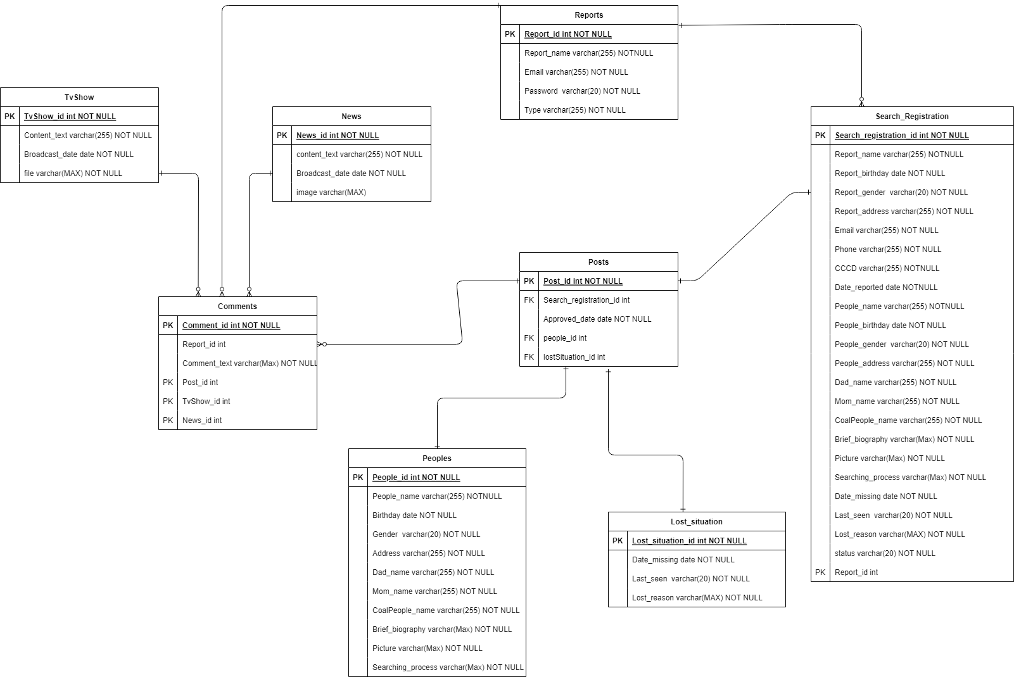

- References
- [SDA] 006 Database Design.docx (Man, Nguyen Duc).
- Pattern: Database per service https://microservices.io/patterns/data/database-per-service.html.
- Microservice Architecture Examples and Diagram: https://www.devteam.space/blog/microservice-architecture-examples-and-diagram/

